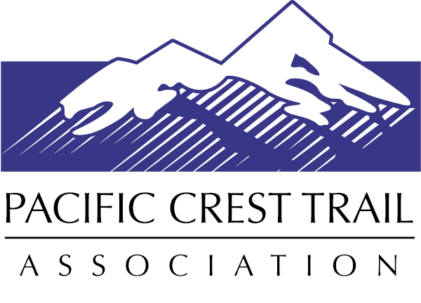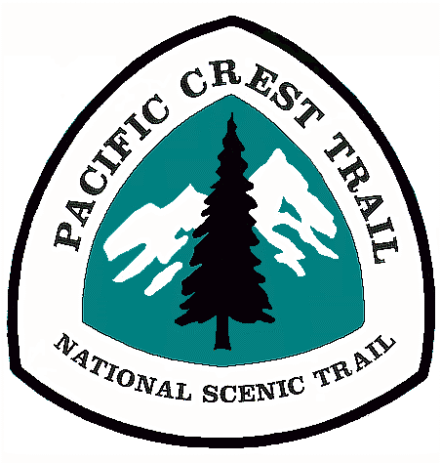Volunteer Application
Contact Information
First Name Middle Initial Last Name
Mailing Address
City State Zip Code
Cell Phone Home Phone Work Phone
Email
Birth Date* Race / Ethnicity* (optional)
*The U.S. Forest Service asks us to collect volunteer demographics to ensure our programs are reaching a diverse population.
This information is confidential. It is only used for the purpose of demographic reporting to the U.S. Forest Service.
Dietary and Medical Information (All information will be kept confidential)
List any medical information the crew leader and/or emergency personnel would need to be aware of in an emergency situation. This information is kept confidential and only used by the crew leader and first aid lead in the event it’s needed. Do any of these conditions prevent you from acting safely on a volunteer trail crew? If none, please write none.
Medical conditions:

Allergies:

Daily medications:

To help us with meal planning on the extended trips, please list any dietary needs or foods and drinks that you prefer to include or exclude from your diet? If none, please write none. Note: We will do our best to accommodate your dietary needs; however, we are unable to provide specific meals, food brands, or other highly specialized requests. If you have any questions regarding food, feel free to contact PCTA Volunteer Programs.

Emergency Contact Information
Name Relation
Cell Phone Home Phone Work Phone
Other Information
What size of t-shirt do you wear?
How did you hear about our volunteer opportunities?

_____ PCTA Website
_____ PCTA Email
_____ PCTA Recruiting / Booth Event
_____ Friend / Family Member
_____ Local Newspaper / Radio
_____ Other

Registration
Is there a volunteer project you would like to register for? Please include the project(s) name and dates here:
1.
2.
Volunteer Interests and Experience
What region would you like to volunteer in? (Check all that apply)
_____ Southern California (Mexico border to Kennedy Meadows)
_____ Southern Sierra Nevada: Central California (Kennedy Meadows through Yosemite NP)
_____ Northern Sierra Nevada: Central and Northern California (Yosemite NP through Lassen NF)
_____ Big Bend Region: Northern California and Southern Oregon (Shasta Trinity NF to Windigo Pass)
_____ Columbia Cascades: Central Oregon and Southern Washington (Windigo Pass to White Pass)
_____ Northern Cascades: Central and Northern Washington (White Pass to Manning Park)

What volunteer positions interest you? (Check all that apply)

_____ Trail Maintainer _____ Office Administration / Events
_____ Trail Crew Cook _____ Packer (Do you have stock available for use? __ Yes __ No)
_____ Trail Crew Leader _____ Other
_____ Trail Scouting & Project Planning
Do you have experience with any of the following? (Check all that apply)

_____ General Trail Maintenance
_____ New Trail Construction
_____ Rigging / Griphoist
_____ Trail Design
_____ Leading Crews or Groups
_____ GPS / Mapping

Briefly describe your hiking, camping, and backpacking experience.

Briefly describe your ability to use hand tools and perform arduous, manual labor.

Briefly describe any physical activities/sports that you participate in, including how often you engage in these activities.
What are you expecting from your experience while volunteering on the Pacific Crest Trail?

Is there anything else you would like us to know about you?

