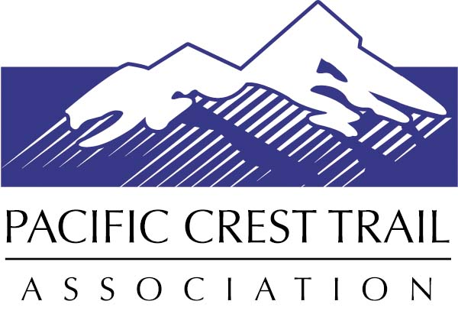
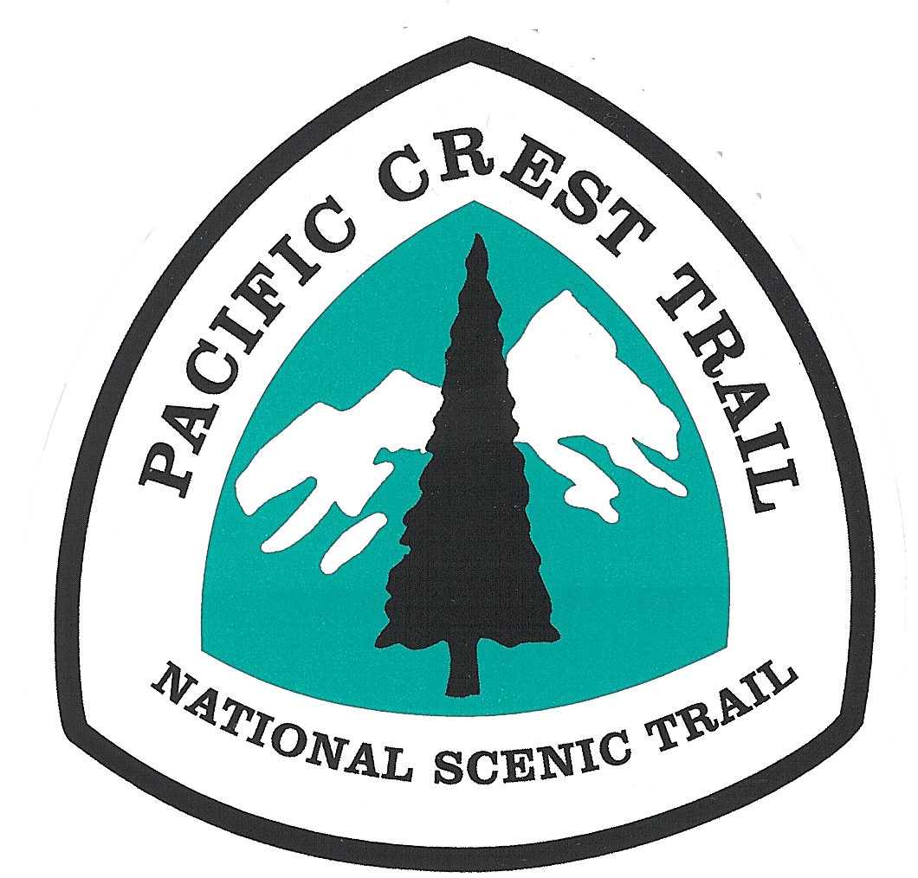

Pacific Crest Trail Association
VOLUNTEER INJURY INSTRUCTIONS

This packet contains information about dealing with injuries of Pacific Crest Trail volunteers. It should be carried by each volunteer leader. Volunteer leaders should be familiar with the contents of this packet and ensure that Trailhead Communication and Emergency Action Plans are in place before an accident resulting in injury occurs.

IF AN INJURY OCCURS, FOLLOW THESE STEPS:
- The First Aid Lead initiates care for the patient(s). Get patient’s medical and emergency contact information from Crew Leader. Write medical or SOAP notes.

- Communications Lead uses Trailhead Communications Plan (TCP) and calls 911 or Dispatcher if needed. Relay pertinent medical or SOAP notes written by the First Aid Lead.

- Get emergency treatment by a medical provider, if needed. (Inform agency authorities first, if possible. See Volunteer Injury Instructions: Treatment Procedures on page 3 for details.)

- Evacuate, send medical and emergency contact information and medical or SOAP note with patient.

- Report injury to agency authorities and PCTA. In non-emergency situations, this notification occurs before formal medical care is sought. See Volunteer Injury Instructions for PCTA Contacts. Agency contacts are listed on TCP.

- Contact the individual named on the injured person’s sign-up sheet.

- Documentation. At a minimum, a form CA-1 (Report of Injury) should be completed by the injured party for all injuries (even if medical treatment is not sought); and witness statements should be included. All injuries should be reported within 24 hours of occurrence.

THIS PACKET INCLUDES:
- Pacific Crest Trail Volunteer Injury Instructions
- PCTA Trailhead Communications Plan (1 sample copy, to be completed for each project)
- PCTA Emergency Action Plan (1 sample copy, to be completed for each project)
- Form SOAP Note (blank – 2 copies)
- Form CA-1 Report of Injury (blank – 2 copies)
- Form PCTA Witness Statement (blank – 2 copies)

For additional copies or to resupply this packet, download forms
from the PCTA website or contact the PCTA at 916-285-1846.
OVERVIEW. A volunteer working on the Pacific Crest National Scenic Trail (PCT) is officially a volunteer of the U.S. Forest Service (USFS), the Bureau of Land Management (BLM) or the National Park Service (NPS), and is entitled to certain protections when safety requirements and current volunteer agreements are in place. These volunteer protections are especially important in case of an injury involving a PCT volunteer. It is important that volunteers, volunteer leaders, and agency partners know what to do in case of an injury involving a PCT volunteer.

VIF/VIP. There are two separate laws which authorize the U.S. Forest Service and National Park Service agencies to work with volunteers and provide them certain protections. VIF (Volunteers in Forests) is the Volunteers in the National Forests Act of 1972 which applies to the USFS. VIP (Volunteers in Parks) is the Volunteers in the National Parks Act of 1969 which applies to NPS.

BLM Volunteers. The authority for the volunteer program in the BLM is found in the Federal Land Policy and Management Act of 1976 (FLPMA), as amended, including amendment by Public Law 980540 of 1984 (BLM Volunteers for the Public Lands Statue), the Federal Tort Claims Act, and Provisions of the United States Code which authorizes compensation for work injuries.

In all three federal agencies, volunteers are considered to be federal employees for purposes of:
- compensation for work-related injuries or illnesses under the Federal Employees Compensation Act (FECA), relating primarily to costs for medical care in case of injury or illness; and
- protection from tort claims, under the Federal Tort Claims Act, which may be filed by anyone who may claim to have sustained personal injury or property damage due to the actions of a volunteer; and
- claims relating to damage or loss of personal property of the volunteer while performing volunteer service.

Volunteers are not considered to be federal employees for purposes of pay, benefits, retirement, or unemployment compensation.

California State Parks Volunteers. Volunteers working on the PCT in California State Parks are covered under the federal agency that the easement is granted to from California State Parks. This will be either the US Forest Service or BLM.

This instruction sheet focuses on PCT Volunteer Injuries, because of their immediate nature. For more information on volunteer work-related illnesses, tort protections, or personal property losses, contact the PCTA’s Trail Operations Manager.

INJURIES: LOCATION, LOCATION, LOCATION. PCT volunteers may be covered by VIF, VIP or BLM depending on where the injury occurs. If you are unclear on which federal agency administers the land, contact the PCTA Regional Representative in the area to find out before your work trip. It is critical that you determine and verify the appropriate agency personnel to contact in case of injury before your work trip and list them on the Trailhead Communications Plan.

- VIF – covers volunteers working on the PCT on National Forest System lands, or lands and/or easements acquired for the PCT and assigned to the Forest Service This is about 69% of the Trail. Including:
  - California: Cleveland, San Bernardino, Angeles, Sequoia, Inyo, Sierra, Humboldt-Toiyabe, Stanislaus, Eldorado, Tahoe, Plumas, Lassen, Shasta-Trinity, and Klamath National Forests and the Lake Tahoe Basin Management Unit;
  - Oregon: Rogue River-Siskiyou, Winema-Fremont, Umpqua, Deschutes, Willamette, and Mt. Hood National Forest, and the Columbia Gorge National Scenic Area;
  - Washington: Gifford Pinchot, Wenatchee-Okanogan, and the Mt. Baker-Snoqualmie National Forests.

- VIP – covers volunteers working on the PCT on National Park lands, or lands and/or easements acquired for the PCT and assigned to the National Park Service lands; totaling about 19% of the Trail. Including:
- California: Sequoia /Kings Canyon, Yosemite, and Lassen National Parks, and the Devils Postpile National Monument;
- Oregon: Crater Lake National Park;
- Washington: Mt. Rainer and North Cascades National Parks.

- BLM – covers volunteers working on the PCT on Bureau of Land Management lands, or lands and/or easements acquired for the PCT and assigned to the Bureau of Land Management; totaling about 12% of the Trail. Including:
- California: Bakersfield, El Centro, Ridgecrest, and Palm Springs;
- Oregon: Medford and the Cascade-Siskiyou National Monument.

INJURIES: BASIC REQUIREMENTS. A PCT volunteer worker must be authorized as a volunteer in writing by the NPS (for VIP), the BLM (for BLM) or the USFS (for VIF). All agencies use one standard form for this Volunteer Services Agreement for Natural Resource Agencies (OMB 0596-0080). It can be done either as an individual, or as a member of a group (sponsored). For more information on volunteer agreements, contact the PCTA’s Trail Operations Manager.

Most traditional PCT volunteers are covered by a sponsored group agreement between their local PCT volunteer group and the NPS, BLM or USFS. Workers must be listed as a participant on a group’s work party by way of a roster. This roster should be completed prior to the beginning of the work trip and after the project should be sent to the PCTA Sacramento office. It is considered an extension of the group agreement.

Volunteers must work within the scope of their volunteer agreement, which includes following basic safety practices. This includes participating in a daily pre-work safety briefing (tailgate safety session), using all required personal protective equipment (PPE), and obtaining required training and certifications for specific tasks (example: chain saw or crosscut saw operation).

Volunteers are not covered by VIF/VIP/BLM if injured during the drive to and from their volunteer work, and they are not compensated for time lost on a paid job due to an injury suffered as a volunteer. The PCTA’s liability coverage covers volunteers driving to and from an organized project.

INJURIES: TREATMENT PROCEDURES
All injuries should be treated on the date of the accident or as soon as possible afterwards. Failure to do this results in higher costs and a poor rating for your agency partner.

- All injuries should be reported to the appropriate PCTA staff and agency personnel as soon as possible, even if you do not seek treatment. If your injury gets worse, you may need treatment at a later date, and it will be hard to prove your injury occurred while working on the PCT without the initial reporting. All injuries should be reported by completing Boxes 1-15 on the CA-1 (Report of Injury) form and two PCTA Witness Statements then submitting them to the PCTA within 24 hours of occurrence. (Note: Please keep copies for your records.)

- If an injury requires emergency medical treatment, get it from the closest source of emergency care. You should plan for this possibility before each trip out to the Trail by completing the Trailhead Communications and Emergency Action Plans.

- Notify the appropriate agency personnel as soon as possible, preferably before arrival at the medical facility. It is critical that you determine and verify the appropriate agency personnel to contact in case of injury before your work trip. Contact information should be listed on the Trailhead Communications Plan.

- Notify the PCTA Regional Representative for the area where the injury occurred. If he/she is unavailable, please call the PCTA Trail Operations Manager at the Sacramento office at 916-285-1846, after business hours 916-243-9923.

Region | Geographic Boundaries | Contact | Phone Number
Southern California | Mexico to Kennedy Meadows | Anitra Kass (Regional Rep.) | 760-977-8684
Southern Sierra | Kennedy Meadows thru Yosemite NP | Jennifer Tripp  (Trail Operations Manager) | 916-243-9923
Northern Sierra | North Boundary of Yosemite NP thru Lassen NF (includes Lassen NF North of the park) | Justin Kooyman (Regional Rep.) | 530-414-3422
Big Bend | Shasta Trinity NF to Windigo Pass | Ian Nelson (Regional Rep.) | 541-778-3252
Columbia Cascades | Windigo Pass to North Boundary of Columbia River Gorge | Dana Hendricks (Regional Rep.) | 541-844-9133
North Cascades | North Boundary of Columbia River Gorge to Manning Park | Bill Hawley (Regional Rep.) | 503-312-3938

- As you seek treatment, you may request to have your medical costs compensated by the U.S. Government due to your status as a volunteer (VIF, VIP, BLM) under FECA. This compensation coverage is through the U.S. Department of Labor, Office of Worker’s Compensation Programs (OWCP). This is federal, not state, OWCP. It is not considered to be “insurance.”

If you are seeking emergency medical treatment and request to have your medical costs compensated by the U.S. Government as a federal volunteer, inform the medical facility that you have been injured as a volunteer for the U.S. Forest Service, National Park Service or Bureau of Land Management, and provide them with the local agency emergency contact information. If the medical facility has concerns, they can contact the U.S. Department of Labor, Office of Worker’s Compensation Programs in Albuquerque, N.M., for additional information and emergency authorization. During regular business hours, call 877-372-7248, option 2, and then option 5 from 7 am to 6 pm Mountain Time.

The OWCP will issue a form CA-16 (Authorization for Examination and/or Treatment). (Note: The physician will keep the original CA-16. Please ask for a copy to submit with the other paperwork in this packet.)

