Accessing and Navigating the PCTA Volunteer Database
STEP 1

Go to www.pcta.org. Go to the Crew Leader Center. You can access the Crew Leader Center two ways:
Option 1: Put your cursor over the green Volunteer button and click on the Crew Leader Center in the pull down menu.
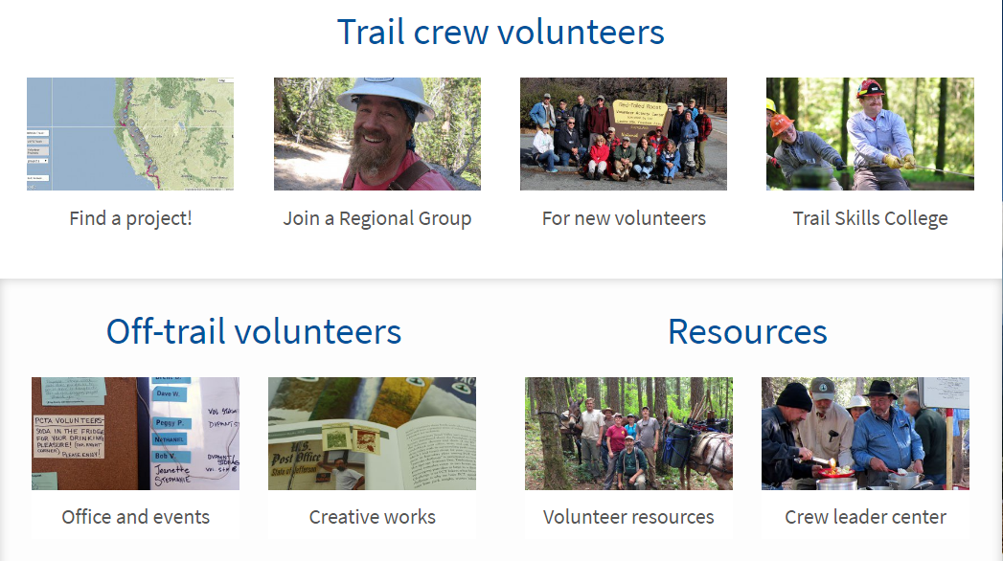
Option 2: Click on the green Volunteer button to be directed to the Volunteer Programs landing page. Scroll down and click on the Crew Leader Center button.

STEP 2

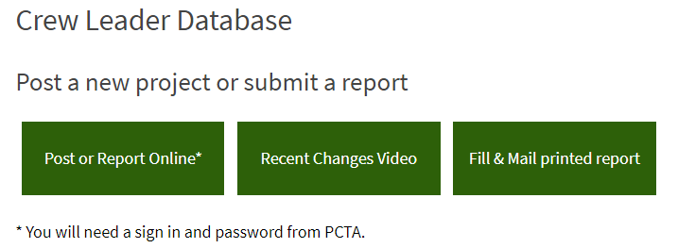
On the Crew Leader Center page, scroll down to the Crew Leader Database. Click Post or Report Online.

STEP 3

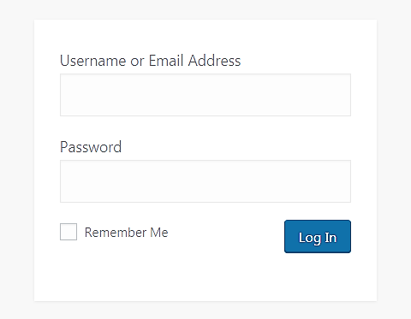
Log in to the Crew Leader Center using the username
and password provided by PCTA.

Passwords are updated annually. If you lose your
password, contact volunteer@pcta.org or (916) 285-1838.

STEP 4

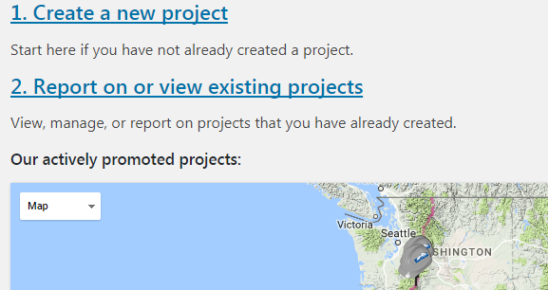
On this landing page you
can create a new project
or view, manage, or report
on existing projects.
On the map, you’ll see all
of your chapters projects
that are actively promoted
on the PCTA project schedule.

