Posting a Project on the PCTA Project Schedule
Before you get started:
- When you submit the online form, the project is not immediately visible on the Project Schedule. It will go to PCTA Volunteer Programs for review and final posting.
- Projects are removed as they occur.
- Please contact PCTA Volunteer Programs if you need to edit your project.
- Email: volunteer@pcta.org
- Phone: (916) 285-1838
STEP 1

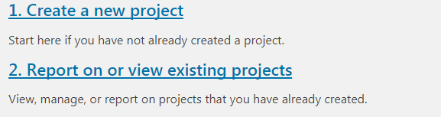
Access the online volunteer database. See “Step 1: How to Access and Navigate the PCTA Volunteer Database.”
Once logged in, click
Create a new project.

STEP 2

Fill out the common information:
- Project Name: If you have multiple projects in the same area, please assign unique project names (i.e. Jackson Meadow Part 1, Jackson Meadow Part 2). See Step 6 to learn how to create a duplicate project.
- Crew Leader
- Volunteer Group: Use the pull-down menu to select the PCTA or partner group organizing the project.
- Agency Unit: Use the pull-down menu to select the partner agency that manages the section of trail where your project takes place.
  - If the project will occur on more than one agency, choose the agency where most of the work will occur.
  - If you do not know the agency, please contact your PCTA Regional Representative.
- Region: After selecting the agency unit, the PCTA region will auto-fill. Correct if needed.
- Date From/Date To: Use the calendar to select the first and last date of your project.
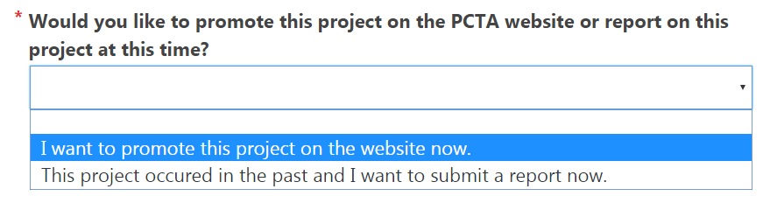
This is common information because it will appear on the PCTA project schedule, and it will appear later on the project report.
Choose I want to
promote this project
on the PCTA
website now.
Then, Submit.
STEP 3

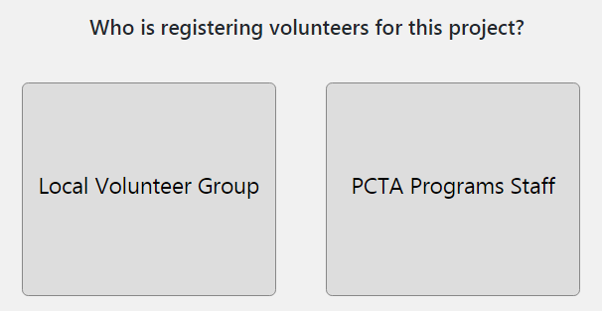
Answer the question Who is
registering volunteers for
this project?
After answering this question
you’ll jump to a new screen with
additional questions.
If PCTA Programs Staff is
registering volunteers for the
project, you need to provide
all the logistics for the project.
The next page will contain
detailed questions, like what
time you will meet volunteers, if you are backpacking, and what time trail work will start and end.
If the Local Volunteer Group is registering volunteers, the next page will contain fewer questions. You will only need to provide information visible on the PCTA project schedule.
STEP 4

If the Local Volunteer Group is registering volunteers, please answer the following required questions:
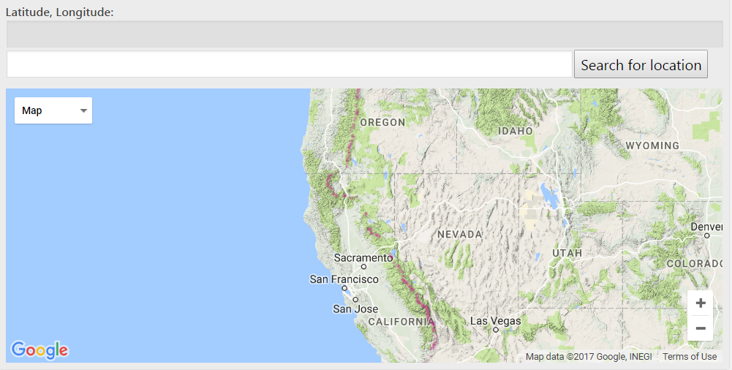
Zoom in on the map or use the search function to find your project location. Click the location on the map. The Latitude, Longitude, and Elevation fields will fill in.
Latitude
Longitude

Elevation

Project description

Experience required

Fitness
level
Hiking
miles

Backpack
miles

Max # of
vol’s
Project
length
How to
register
Space
available

Click Submit Form.
PCTA Volunteer Programs will be notified that you’ve created a project. It will be posted on the online Project Schedule soon. Contact volunteer@pcta.org or (916) 285-1838 to edit the project.

STEP 5

If PCTA Programs Staff is registering volunteers, answer these additional questions:
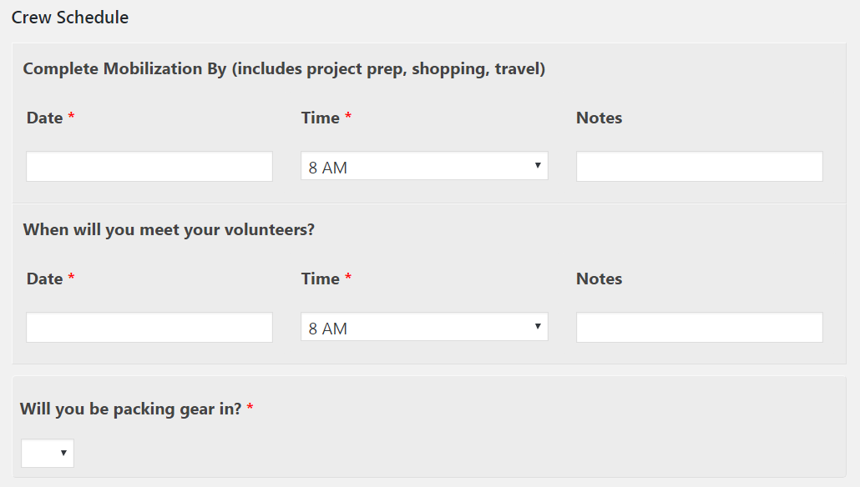
Mobilize
date/time

Date/time
to meet
vol’s
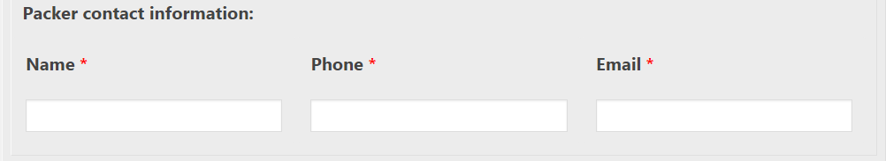
Pack-
support

Packer
contact
Back-
packing

Trail
work
starts

Trail
work
ends

Pack-
support

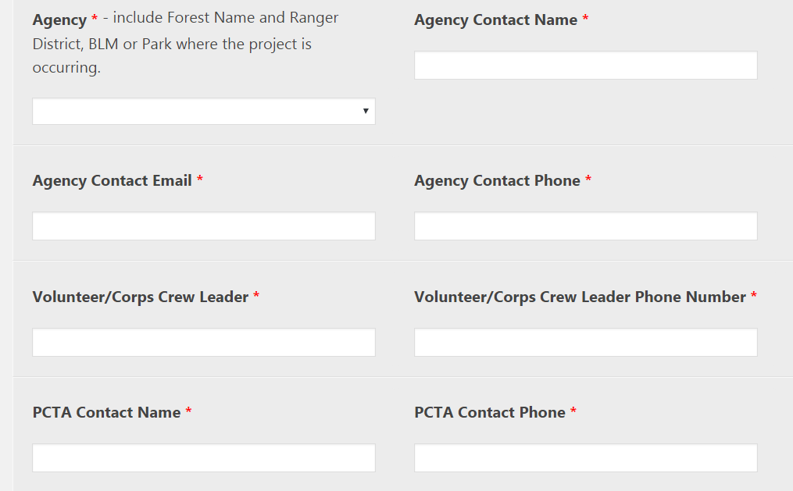
Agency
contact

Crew
leader
contact

PCTA
contact

Location
Tools
Safety
Concern

Camp

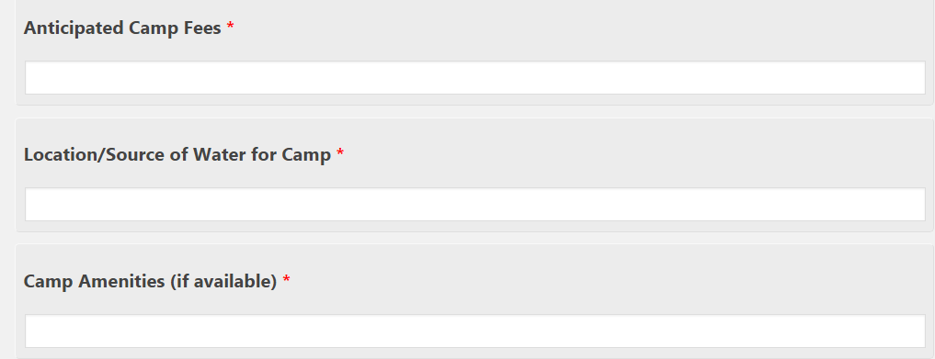
Fees

Water

Other

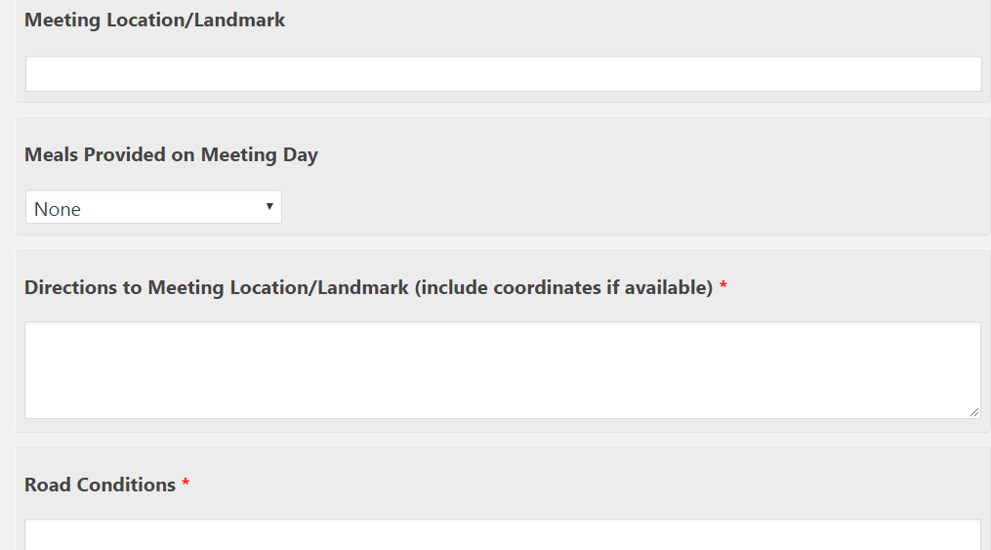
Meeting
location

Meals

Driving
directions
Condition
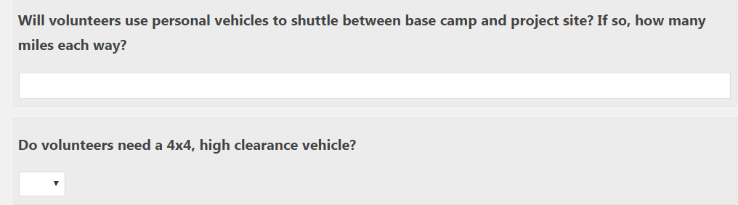
Daily
mileage

4x4

Other
notes

Click Submit Form.
PCTA Volunteer Programs will be notified that you’ve created a project. It will be posted on the online Project Schedule soon. Contact volunteer@pcta.org or (916) 285-1838 to edit the project.

STEP 6
To create a similar project, click Report on
or view existing projects.

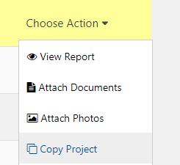
Find your project in the Project List,
click Choose Action,
then Copy Project.

Assign a new name to the new project and edit details as needed.
Click Submit Form.
PCTA Volunteer Programs will be notified that you’ve created a project. It will be posted on the online Project Schedule soon. Contact volunteer@pcta.org or (916) 285-1838 to edit the project.

