How to Submit a PCTA Project Report Form
STEP 1

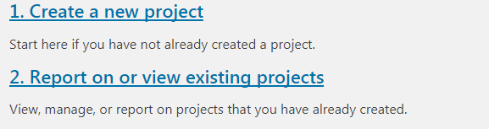
Access the online volunteer database. See “Step 1: How to Access and Navigate the PCTA Volunteer Database.”
Did you already Create the
project?
No – move to step 2
Yes – move to step 7
STEP 2
Click Create a new project.
Fill out the common information:
- Project Name
- Crew Leader
- Volunteer Group:
Use the pull-down menu
to select the PCTA or partner group organizing the project.
- Agency Unit: Use the pull-down menu to select the partner agency that manages the section of trail where your project took place.
  - If the project is not affiliated with a particular agency unit, please select PCTA.
  - If the project occurred on more than one unit, please submit a separate report for each unit, and divide the volunteer hours and accomplishments accordingly.
  - If you do not know the appropriate agency unit, please contact your PCTA Regional Representative.
- Region: After selecting the agency unit, the region field will auto-fill. Correct if needed.
- Date From/Date To: Use the calendar to select the first and last date of your project.
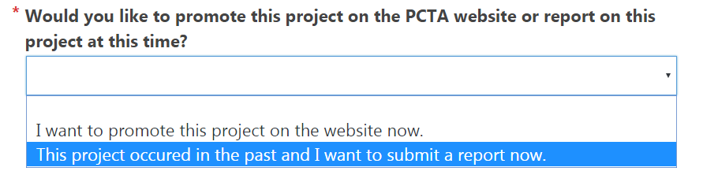
Choose This project
occurred in the past
and I want to submit
a report now.
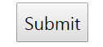
Then, Submit.

STEP 3

Fill in the remainder of the report form.
- # of Stock Used
- Youth Project
Was this project specifically for youth volunteers? (for example, a group of Boy Scouts?) If so, check the box.
- Describe the section of trail on which the project took place
You can use GPS points, trail miles, or other identifying features.
- How many miles of trail did you do maintenance on – excluding logout.
This includes annual maintenance tasks such as brushing, drainage maintenance, and minor tread repair. Logout miles should be recorded in the logout section. Round to tenths of a mile.
- How many feet of rehabilitation and/or reconstruction did you complete?
This includes work done to bring the trail up to standard, such as redigging sloughed tread, installing or reconstructing drainages, rebuilding or realigning the tread, and/or removing major obstructions.
- Was this a log out project?
These are miles of trail that only received logout work. Round to tenths of a mile.
- Overview of the work accomplished during project.
- Total number of volunteers on this project
Enter the number of volunteers. Click Update. Rows will be added to the form. If you change the number of volunteers and click Update again, rows will be added/deleted from the bottom of the list.
- Listing each volunteer and their hours
- Specialized hours are spent doing certified saw work, packing, rigging, drilling, and leading crews.
- Corps Crew refers to volunteers on partner corps crews, like American Conservation Experience (ACE). If your volunteer is a corps crew member or leader, please indicate this in the drop down menu. Volunteers not affiliated with corps crews can remain N/A.
- Did you complete any of the following major structures?
- Summary will be emailed to the following
- PCTA Regional Rep: this is pre-filled according to the Region at the top of the report.
- PCTA Volunteer Coordinator: all report forms are sent to volunteer@pcta.org.
- My email: please enter your email address.
- Agency Partner email(s): this is pre-filled according to the Agency at the top of the report.
Additional field: Please enter email addresses for anyone else you feel should receive a copy of your report.
- Would you like to upload Photos, JHAs, or Sign in Sheets for this project?
STEP 4

Click Send Report.
STEP 5
Are you uploading photos or documents with your report?
No - you will see a confirmation that your report was submitted. You can come back at any time to upload photos and documents.
Yes - you will see a confirmation that
your report was submitted. Click the
button for the type of file you’d like to
attach.

There are separate upload pages for photos and documents, but they function the same. Browse for the files you’d like to upload, or drag and drop your files into the box. For photos, please provide the photographer’s name and email.
Once you find your documents, Upload these files.
You will see notifications as the upload
processes, and a green check mark when complete.

STEP 6

Once your files are uploaded, you’ll see them on the Project List. You can click the icons to view the files.
To upload more photos or documents, click Choose Action and Attach
Documents or Attach Photos.

STEP 7
If you already created the project,
click Report on or view existing
projects.

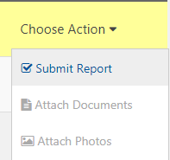
Find your project in the Project List, click Choose Action,
then Submit Report.

Fill in the questions described in Step 3.

