Marking a Project “Full” on the PCTA Project Schedule
STEP 1

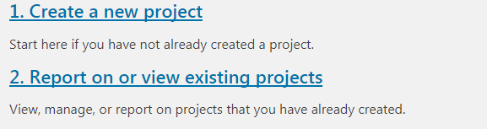
Access the online volunteer database. See “Step 1: How to Access and Navigate the PCTA Volunteer Database.”
Once logged in, click
Report on or view
existing projects.
STEP 2
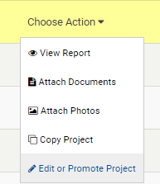
Find your project in the Project List,
click Choose Action,
then Edit or Promote Project.

STEP 3
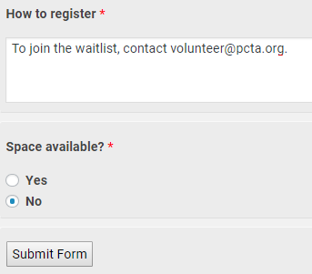
Scroll to the bottom of the screen.
Under the last question,
Space available? click No.
If a waitlist is available, update the
How to register instructions.
Example: “To join the waitlist,
please contact volunteer@pcta.org”
Click Submit Form.
PCTA Volunteer Programs will be notified that
you’ve edited the project. The changes will be
approved soon and Project Full will appear on
the online Project Schedule.

