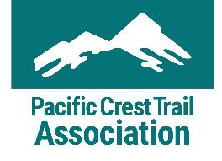
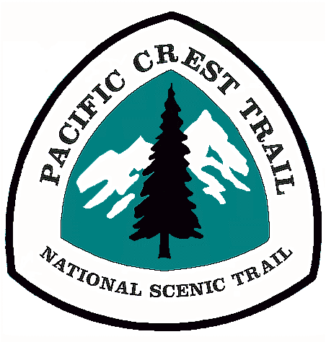
Volunteer Application
Contact Information
First Name Middle Initial Last Name
Mailing Address
City State Zip Code
Cell Phone* Home Phone Work Phone
*By providing your mobile phone number, PCTA has your permission to contact you at that number. You may contact PCTA at any time to change this preference.
Email
Birth Date** ____________________ Gender** _____________ Race/Ethnicity**
**PCTA collects volunteer demographics to ensure our programs are reaching a diverse population. This information is confidential. It is only used for the purpose of demographic calculations, and nothing else.
Dietary and Medical Information
List medical information the crew leader and/or emergency personnel need to be aware of in an emergency situation. If none, please write none. This information is kept confidential and only used by the crew leader and first aid lead as needed.
Medical conditions
Daily medications
Allergies (Food-related allergies should also be listed under dietary needs.)

Dietary needs (Restrictions or food allergies that crew leaders should consider in meal planning. We do our best to accommodate dietary needs, however, we may be unable to meet highly specialized requests. If none, please write none.)

When you’re doing trail work or other continuous physical activity, are you a:
_____ Light eater _____ Average eater _____ Big eater
Emergency Contact Information
Name Relation
Cell Phone Home Phone Work Phone
Other Information
What size t-shirt do you wear?
How did you hear about our volunteer opportunities?

_____ PCTA Website
_____ PCTA Email
_____ PCTA Recruiting/Booth Event
_____ Friend/Family Member
_____ Local Newspaper/Radio
_____ Other

Registration
Is there a volunteer project you would like to register for? Please include the project name(s) and date(s):
1.
2.
Volunteer Interests and Experience
Where would you like to volunteer? (This might be on the trail, in an office, or at an event.)
_____ Southern California (Mexico border to Kennedy Meadows)
_____ Southern Sierra: Central California (Kennedy Meadows through Yosemite National Park)
_____ Northern Sierra: Central and Northern California (Yosemite National Park through Lassen National Forest)
_____ Big Bend: Northern California and Southern Oregon (Shasta Trinity National Forest to Windigo Pass)
_____ Columbia Cascades: Central Oregon and Southern Washington (Windigo Pass to White Pass)
_____ North Cascades: Central and Northern Washington (White Pass to Manning Park)

What volunteer positions interest you?

_____ Trail Maintainer
_____ Trail Crew Cook
_____ Trail Crew Leader
_____ Office Administration
_____ Packer (Do you have stock available for use? ___Yes ___ No)
_____ Events
_____ Other ___________
______________________
Do you have experience with any of the following?

_____ General Trail Maintenance
_____ Trail Design
_____ New Trail Construction
_____ Leading Crews or Groups
_____ Rigging/Griphoist
_____ GPS/Mapping
Briefly describe your hiking, camping, and backpacking experience.
Briefly describe your ability to use hand tools and perform arduous, manual labor.
Briefly describe any physical activities/sports you participate in, including how often you engage in these activities.
What are you expecting from your volunteer experience with the Pacific Crest Trail Association?
Are there other skills you would like to volunteer or is there anything else you would like us to know about you?

