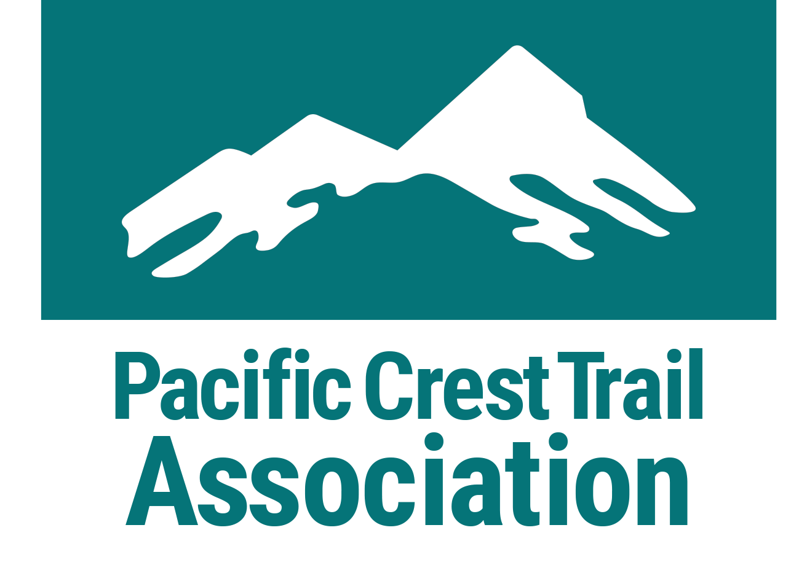
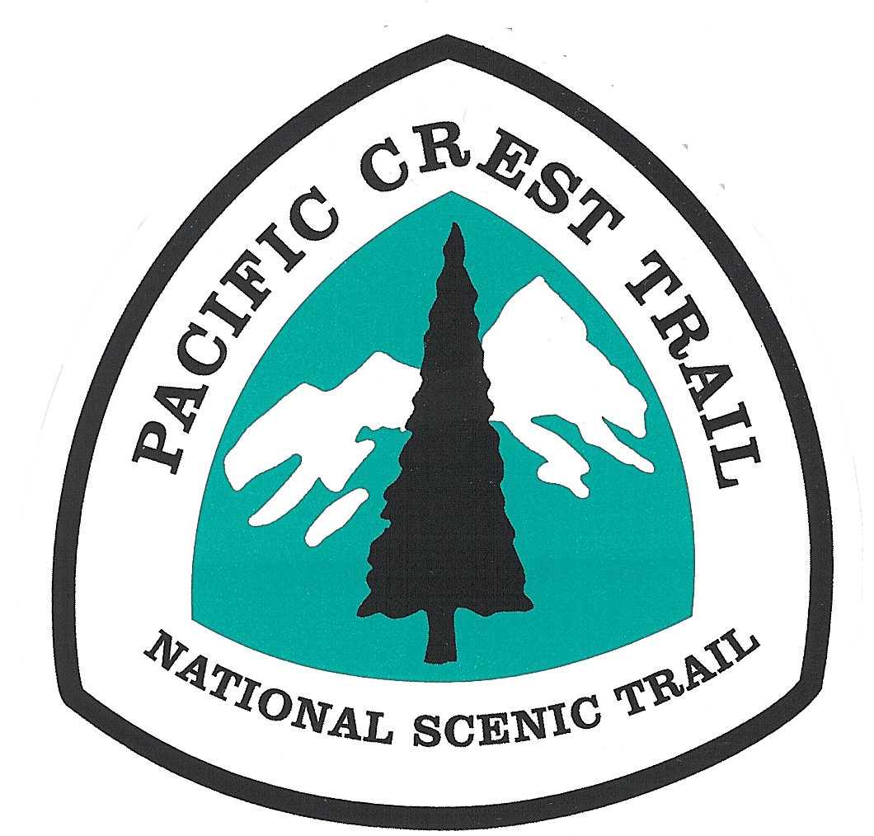
Pacific Crest Trail Association
VOLUNTEER INJURY INSTRUCTIONS
PCTA’s Volunteer Injury Packet contains information about dealing with injuries of Pacific Crest Trail volunteers. Volunteer leaders should be familiar with the contents of this packet, carry it on each outing, and ensure that Trailhead Communication and Emergency Action Plans are in place before an accident resulting in injury occurs.

IF AN INJURY OCCURS, FOLLOW THESE STEPS:
- First Aid Lead initiates care for the patient. Get patient’s medical and emergency contact information from Crew Leader. Write medical or SOAP notes.

- Communications Lead uses Trailhead Communication Plan (TCP) and calls Primary Agency Dispatch Center or 911. Relay pertinent medical or SOAP notes written by the First Aid Lead. Do not relay patient’s first and last name.

- If needed, get emergency treatment by a medical provider. If possible, inform agency authorities first. See TCP for agency contacts.

- Report injury to agency authorities and PCTA. In non-emergency situations, this notification occurs before formal medical care is sought. See TCP for agency and PCTA contacts. All injuries should be reported within 24 hours.
- Evacuate patient and send following documents with patient: medical and emergency contact information, SOAP note, TCP. Transportation can be provided by any member of the crew, PCTA staff or agency partner.
The injured volunteer can and may use any insurance, in whole or in combination, he/she has available as a private citizen. If the injured chooses to use federal workers’ compensation coverage, medical providers must be enrolled with an OWCP FECA provider (Office of Workers’ Compensation Programs, Federal Employee’s Compensation Act). More information on Page 2.

- Contact the patient’s emergency contact.

SUBMIT ALL DOCUMENTATION TO AGENCY AND PCTA:
- Patient should complete Form CA-1 (Report of Injury), even if medical treatment is not sought.

- SOAP Note and Witness Statements should be completed.

- Additional documentation is required if patient uses federal workers’ compensation coverage for medical treatment. See Page 2.

THIS PACKET INCLUDES:
- Pacific Crest Trail Association Volunteer Injury Instructions
- PCTA Trailhead Communication Plan: 1 sample copy
- PCTA Emergency Action Plan: 1 sample copy
- PCTA Witness Statement: 2 copies
- Form CA-1 Report of Injury: 2 copies
- SOAP Note: 2 copies
For additional copies or to resupply this packet, download forms
from www.pcta.org or contact PCTA at 916-285-1838.
ADDT’L DOCUMENTATION FOR FEDERAL WORKERS’ COMPENSATION:
- As you seek treatment, you may request to have your medical costs compensated by the U.S. Government due to your status as a volunteer. See Page 3: Laws that Protect Volunteers.
This compensation coverage is through the U.S. Department of Labor, OWCP. This is federal, not state, OWCP. It is not considered to be “insurance.”

- Medical providers must be enrolled with an OWCP FECA provider. Visit OWCP’s online portal (https://owcpmed.dol.gov/portal/main.do) to search providers.

- If you are seeking emergency medical treatment, inform the medical facility that you have been injured as a volunteer for the U.S. Forest Service, National Park Service or Bureau of Land Management, and provide them with the local agency contact information.
If the medical facility has concerns, they can contact the U.S. Department of Labor, OWCP in Albuquerque, N.M., for additional information and emergency authorization. During regular business hours, call OWCP at (877) 372-7248, option 2, then option 5 from 7 AM-6 PM Mountain Time.

- For non-emergency treatment, contact OWCP at (877) 372-7248 to issue a form CA-16 (Authorization for Examination and/or Treatment). Form CA-16 can be issued up to 48 hours after seeking medical treatment or up to 7 days after the date of injury if the injured worker has not sought treatment.

- Have the physician complete CA-16. Ask for a copy of the completed form. Once you have received treatment you must obtain medical documentation that clearly lists a diagnosis and is signed or countersigned by an MD or DO. Submit documentation to agency and PCTA contacts.

- Agency partner submits and certifies the incident and supporting documents in eSafety to file the workers’ compensation claim.
- The patient will receive an email once the Department of Labor has assigned a claim number. Patient may also retrieve claim number by calling OWCP at (877) 372-7248.
It is the patient’s responsibility to provide the DOL claim number to all medical providers for billing. Failure to do so may result in bills being sent to collections. If bills go into collections, OWCP cannot reverse the process.

OVERVIEW. A volunteer working on the Pacific Crest National Scenic Trail (PCT) is officially a volunteer of the U.S. Forest Service (USFS), the Bureau of Land Management (BLM) or the National Park Service (NPS), and is entitled to certain protections when safety requirements and current volunteer agreements are in place. These volunteer protections are especially important in case of an injury involving a PCT volunteer. It is important that volunteers, volunteer leaders, and agency partners know what to do in case of an injury involving a PCT volunteer.

Laws that Protect Volunteers: VIF/VIP. There are two separate laws which authorize the U.S. Forest Service and National Park Service agencies to work with volunteers and provide them certain protections. VIF (Volunteers in Forests) is the Volunteers in the National Forests Act of 1972 which applies to the USFS. VIP (Volunteers in Parks) is the Volunteers in the National Parks Act of 1969 which applies to NPS.

BLM Volunteers. The authority for the volunteer program in the BLM is found in the Federal Land Policy and Management Act of 1976 (FLPMA), as amended, including amendment by Public Law 980540 of 1984 (BLM Volunteers for the Public Lands Statue), the Federal Tort Claims Act, and Provisions of the United States Code which authorizes compensation for work injuries.

In all three federal agencies, volunteers are considered to be federal employees for purposes of:
- compensation for work-related injuries or illnesses under the Federal Employees Compensation Act (FECA), relating primarily to costs for medical care in case of injury or illness; and
- protection from tort claims, under the Federal Tort Claims Act, which may be filed by anyone who may claim to have sustained personal injury or property damage due to the actions of a volunteer; and
- claims relating to damage or loss of personal property of the volunteer while performing volunteer service.

Volunteers are not considered to be federal employees for purposes of pay, benefits, retirement, or unemployment compensation.

California State Parks Volunteers. Volunteers working on the PCT in California State Parks are covered under the federal agency that the easement is granted to from California State Parks. This will be either the US Forest Service or BLM.

This instruction sheet focuses on PCT Volunteer Injuries, because of their immediate nature. For more information on volunteer work-related illnesses, tort protections, or personal property losses, contact the PCTA’s Director of Trail Operations.
INJURIES: BASIC REQUIREMENTS. A PCT volunteer worker must be authorized as a volunteer in writing by the NPS (for VIP), the BLM (for BLM) or the USFS (for VIF). All agencies use one standard form for this Volunteer Services Agreement for Natural Resource Agencies (OMB 0596-0080). It can be done either as an individual, or as a member of a group (sponsored). For more information on volunteer agreements, contact the PCTA’s Director of Trail Operations.

Most traditional PCT volunteers are covered by a sponsored group agreement between their local PCT volunteer group and the NPS, BLM or USFS. Workers must be listed as a participant on and sign the PCTA Volunteer Sign-In Sheet. The Sign-In Sheet and appropriate Job Hazard Analyses (JHAs) must be reviewed and signed prior to the beginning of the work trip and after the project should be sent to the PCTA Sacramento office. It is considered an extension of the group agreement.

Volunteers must work within the scope of their volunteer agreement, which includes following basic safety practices. This includes participating in a daily pre-work safety briefing (tailgate safety session), using all required personal protective equipment (PPE), and obtaining required training and certifications for specific tasks (example: chain saw or crosscut saw operation).

Volunteers are not covered by VIF/VIP/BLM if injured during the drive to and from their volunteer work, and they are not compensated for time lost on a paid job due to an injury suffered as a volunteer. The PCTA’s liability coverage covers volunteers driving to and from an organized project.
INJURIES: LOCATION, LOCATION, LOCATION. PCT volunteers may be covered by VIF, VIP or BLM depending on where the injury occurs. If you are unclear on which federal agency administers the land, contact the local PCTA Regional Representative to find out before your work trip. It is critical that you determine and verify the appropriate agency personnel to contact in case of injury before your work trip and list them on the TCP.

- VIF – covers volunteers working on the PCT on National Forest System lands, or lands and/or easements acquired for the PCT and assigned to the Forest Service This is about 69% of the Trail. Including:
  - California: Cleveland, San Bernardino, Angeles, Sequoia, Inyo, Sierra, Humboldt-Toiyabe, Stanislaus, Eldorado, Tahoe, Plumas, Lassen, Shasta-Trinity, and Klamath National Forests and the Lake Tahoe Basin Management Unit;
  - Oregon: Rogue River-Siskiyou, Winema-Fremont, Umpqua, Deschutes, Willamette, and Mt. Hood National Forest, and the Columbia Gorge National Scenic Area;
  - Washington: Gifford Pinchot, Okanogan-Wenatchee, and the Mt. Baker-Snoqualmie National Forests.
- VIP – covers volunteers working on the PCT on National Park lands, or lands and/or easements acquired for the PCT and assigned to the National Park Service lands; totaling about 19% of the Trail. Including:
- California: Sequoia/Kings Canyon, Yosemite, and Lassen Volcanic National Parks, and the Devils Postpile National Monument;
- Oregon: Crater Lake National Park;
- Washington: Mt. Rainer and North Cascades National Parks.
- BLM – covers volunteers working on the PCT on Bureau of Land Management lands, or lands and/or easements acquired for the PCT and assigned to the Bureau of Land Management; totaling about 12% of the Trail. Including:
- California: Bakersfield, El Centro, Ridgecrest, and Palm Springs;
- Oregon: Medford and the Cascade-Siskiyou National Monument.

PCTA Regional Representatives
Region | Geographic Boundaries | Contact | Phone Number
Southern California | Mexico to North Boundary of Angeles NF | Anitra Kass | 760-977-8684
Southern Sierra | North Boundary of Angeles NF thru Yosemite NP | Ben Barry | 916-847-4393
Northern Sierra | North Boundary of Yosemite NP thru Lassen NF (includes Lassen NF North of the park) | Connor Swift | 530-570-8276
Big Bend | Shasta Trinity NF to  Windigo Pass | Ian Nelson | 541-778-3252
Columbia Cascades | Windigo Pass to Potato Hill (Road 5603) | Dana Hendricks | 541-844-9133
North Cascades | Potato Hill (Road 5603) to Manning Park | Michael DeCramer | 206-295-9359

