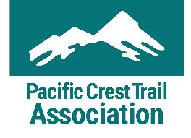
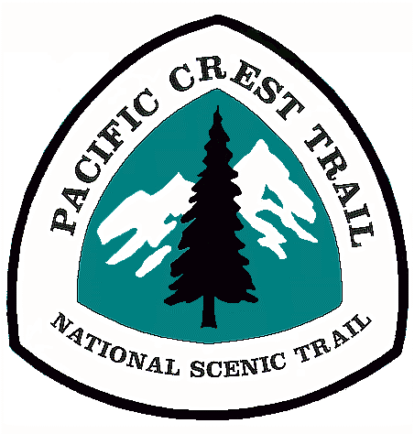
Volunteer Application
Contact Information
First Name Middle Initial Last Name
Mailing Address
City State Zip Code
Cell Phone* Home Phone Work Phone
*By providing your cell phone, PCTA has your permission to contact you at that number. You may contact PCTA at any time to change this preference.
Email
Birth Date** ____________________ Gender** __________________________ Race/Ethnicity** ____________________
**PCTA collects volunteer demographics to ensure our programs are reaching a diverse population. This information is confidential. It is used for the purpose of demographic calculations, and nothing else. If you’re under 18 years old, please complete the Emergency Medical Release and Participant Waiver.
Emergency Contact Information
Name Relation
Cell Phone Home Phone Work Phone
My Interests
What kind of volunteer work are you interested in? Please complete additional questions on Pages 2-3 for each category checked.
_____ Administrative: Data entry, filing, mailings, surveys, and more. These projects usually take place in our
Sacramento office, but may be available in a regional office or as a remote volunteer project.
_____ Education/Awareness: Share your PCT knowledge at tabling events, as a trailhead host, trail information
volunteer, and more.
_____ Media/Publishing: Contribute to PCTA’s publishing channels, like our website, magazine, and social media.
You can volunteer as a writer, moderator, photographer, videographer, and more.
_____ Trail Maintenance: Dig in the dirt, cut back overgrown brush, clear fallen logs, maintain tools, steward a
section of trail, and more.
_____ Other: __________________________________________________________________________________
Where would you like to volunteer?

_____ Southern California
_____ Southern Sierra: Central California
_____ Northern Sierra: N. California
_____ Big Bend: N. California through S. Oregon
_____ Columbia Cascades: Central Oregon through
S. Washington
_____ North Cascades: Central and N. Washington
Is there a specific volunteer project you would like to register for? Please include project name(s) and date(s).

1.___________________________________________ 2._____________________________________________
Administrative
Are you available to volunteer during typical business hours? (Monday-Friday, 9AM-5PM) _____ Yes _____ No
Briefly describe your experience with administrative work, including working on computers.
Optional: please attach your recent resume, if available.
Education/Awareness
Briefly describe your knowledge of and experience on the PCT.
Briefly describe your outdoor experience, including hiking, camping, and backpacking.
Briefly describe your experience providing education, information, and/or customer service.
Media/Publishing
If interested in photography/videography, do you have access to a high-quality camera? _____ Yes _____ No
Please attach up to three examples of your media/publishing work (writing, photo/video, etc.).
Briefly describe your experience with media/publishing.
Optional: please attach your recent resume, if available.
Trail Maintenance
Please list any medical information the crew leader and/or emergency personnel need in an emergency situation. This is kept confidential and only used in the event it is needed. If none, please write none.
Medical conditions
Daily medications
Allergies (food-related allergies should also be listed under dietary needs)

Please list any dietary needs, restrictions, or food allergies we should consider in meal planning. We do our best to accommodate dietary needs, however, we may be unable to meet highly specialized requests. If none, please write none.
What size t-shirt do you wear? _____ Small _____ Medium _____ Large _____ X Large _____ XX Large
When you’re doing trail work or other continuous physical activity, are you a:
_____ Light eater _____ Average eater _____ Big eater
Trail Maintenance (Continued)
Which trail crew roles interest you?

_____ Trail Crew Cook
_____ Trail Crew Member
_____ Trail Crew Leader
_____ Packer (Packers load
and ride packstock like horses and
mules to support backcountry trail
crews. If interested, do you have
stock available? ___Yes ___No)
Are there specific groups you would like to volunteer with? Visit www.pcta.org/volunteer/regional-groups to see where these groups volunteer.
_____ Can Do Crew
_____ Carsonora Crew
_____ Mid-Oregon Volunteers
_____ Mount Hood Chapter
_____ NorCal Trail Crew
_____ North 350 Blades
_____ Pounder’s Promise
_____ Skyline-Sasquatch
Volunteer Vacations
_____ Southern Oregon Rockers _____ Trail Gorillas: San Diego
_____ Trail Gorillas: Paradise
_____ Trail Gorillas: Cajon Pass
_____ Trail Gorillas: LA Gateway _____ Trail Gorillas: San Gabriel
Mountains
_____ Will Work for Krumms _____ White Pass Chapter
_____ Other ________________
Briefly describe your hiking, camping, and backpacking experience.
Briefly describe your ability to use hand tools and perform arduous, manual labor.
Briefly describe any physical activities/sports you participate in, including how often you engage in these activities.
Additional Information
How did you hear about our volunteer opportunities?

_____ PCTA Website
_____ PCTA Email
_____ PCTA Booth/Event
_____ Friend/Family Member
_____ Local Newspaper/Radio
_____ Other
What are you expecting from your volunteer experience with the Pacific Crest Trail Association?

Are there other skills you would like to volunteer or is there anything else you’d like us to know about you?

