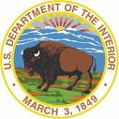 | United States Department of the Interior  NATIONAL PARK SERVICE  Devils Postpile National Monument  P.O. BOX 3999  Mammoth Lakes, CA 93546 | 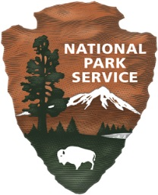

PUBLIC SAFETY CLOSURE

Under the authority of 54 U.S.C. Section 100751(a) and Title 36 Code of Federal Regulations §1.5 (a) (1) the Superintendent is closing the following portion of the park to all public use.
The entirety of Devils Postpile National Monument is closed to all public entry beginning at 12:00 pm on August 31, 2021. Devils Postpile National Monument, which lies completely within the boundaries of the Inyo National Forest, is closed to public entry in support of the Emergency Forest Closure Order issued August 30, 2021 by the Regional Forester, Region 5, United States Forest Service.
This closure order is in effect when signed by the Superintendent and remain in effect until rescinded. Administrative exemptions to this order exist for staff of Devils Postpile National Monument, approved contractors and personnel operating in support of this closure order, infrastructure protection, and life safety operations

______________________________________ _____________
Kevin J. Killian Date
Acting Superintendent

